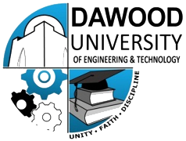
DAWOOD UNIVERSITY OF ENGINEERING & TECHNOLOGY, KARACHI, PAKISTAN.
(Department of Chemical Engineering)
English Proficiency Certificate

It is certified that DUET Karachi runs a 4 year engineering degree in the field of Chemical Engineering. The institute works under the aegis of Higher Education Commission of Pakistan (HEC) and is run under (DAWOOD UNIVERSITY OF ENGINEERING AND TECHNOLOGY, Karachi).

Also Pakistan Engineering Council (PEC) accreditates the degree.
This is to certify that medium of instruction for all the subjects covered (theory & practical) in “Dawood University of Engineering & Technology” during the 4 year of Bachelors of Sciences (B.E.) in Chemical Engineering program is ENGLISH.

Further, NAME s/o, d/o FATHER NAME a graduate of this institute, passed in year 2014 has sufficient proficiency in ENGLISH LANGUAGE that will enable him to easily pursue his studies in English or to adjust in any English spoken country.

Registrar:

_________________________

